Producer Application Guide

# 1. Summary

The Producer Application is at the centre of the whole ProductChain. It is responsible for creating new QR codes to stick on products and moving products between different producers.

# 2. Requirements

* Android 6.0 or newer
* Application size: 2.81MB
* Phone must have Bluetooth
* Phone must have an internet connection.
* All servers and blockchain nodes must be operational before the ProducerApplication can be used.
* Bluetooth Beacon to move products

## 2.1 Permissions

* android.permission.ACCESS_NETWORK_STATE
* android.permission.INTERNET
* android.permission.WRITE_EXTERNAL_STORAGE
* android.permission.BLUETOOTH
* android.permission.BLUETOOTH_ADMIN

# 3. Installation guide

1. Open the Producer Application project in Android Studio

2. Update the NXT_BLOCKCHAIN_REMOTE variable to reflect the remote NXT blockchain address

3. Update the NXT_BLOCKCHAIN_LOCAL variable to reflect the local NXT blockchain address

4. Update the CACHING_SERVER variable to reflect the caching server address

5. Update the VERIFICATION_SERVER variable to reflect the verification server address

6. Update the QR_CODE_GEN_SERVER variable to reflect the QR code generating server address

7. Update the PRODUCT_CHAIN_NXT_ADDR variable to reflect the Product Chain NXT address.

8. Run the application to install it to the Android Device.

# 4. Display Sequence

## Task 1 – Create new Product QR code

Step 1. Open the application and select *Request new QR code*.

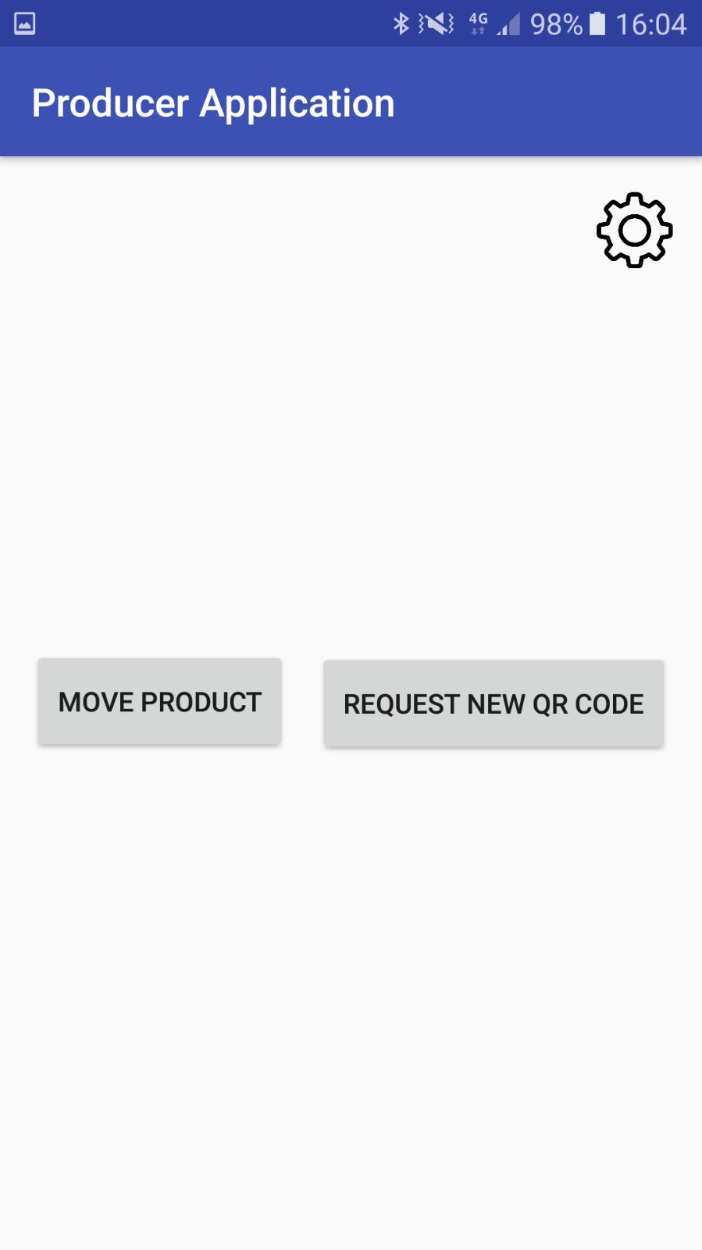

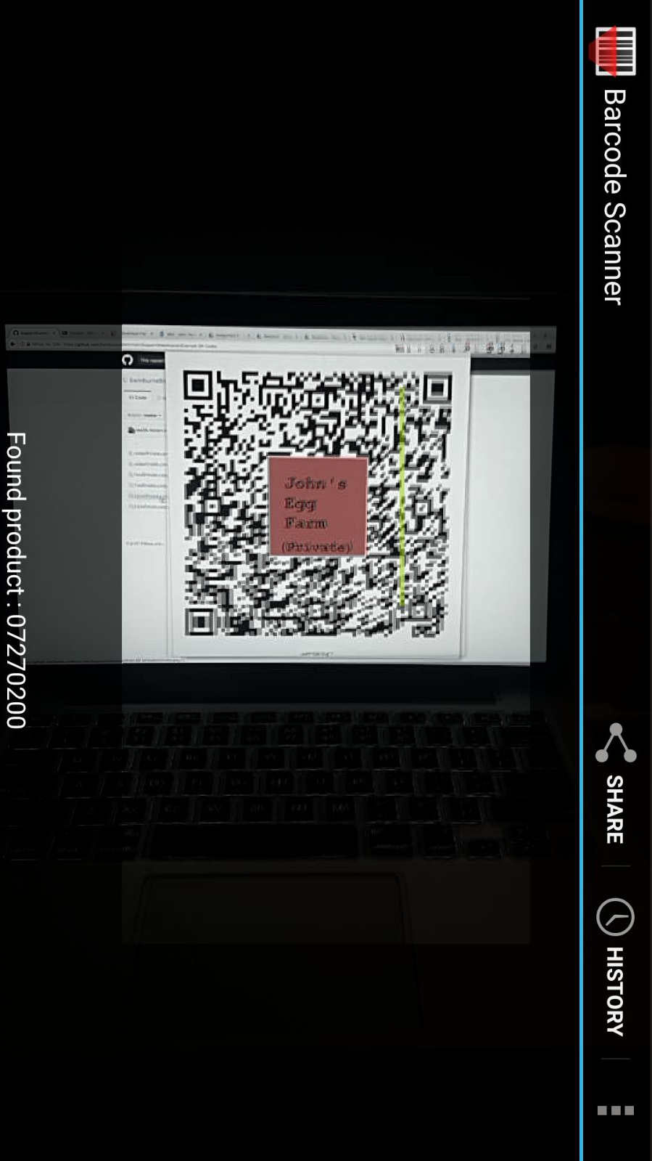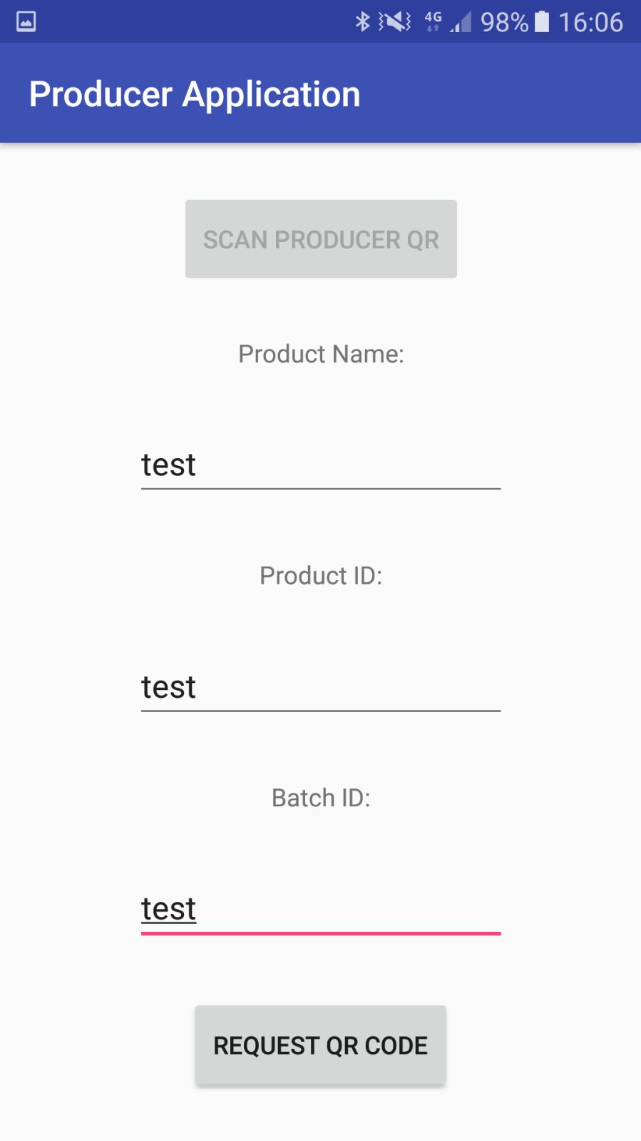Step 2. Fill in the information about the product and scan the Producer *Private* QR code.

Step 3. A generated QR code will display on the screen. *Save to camera roll* can be pressed to save a copy of the QR code to the camera roll, where it will be stored and can later be printed and applied to a product.

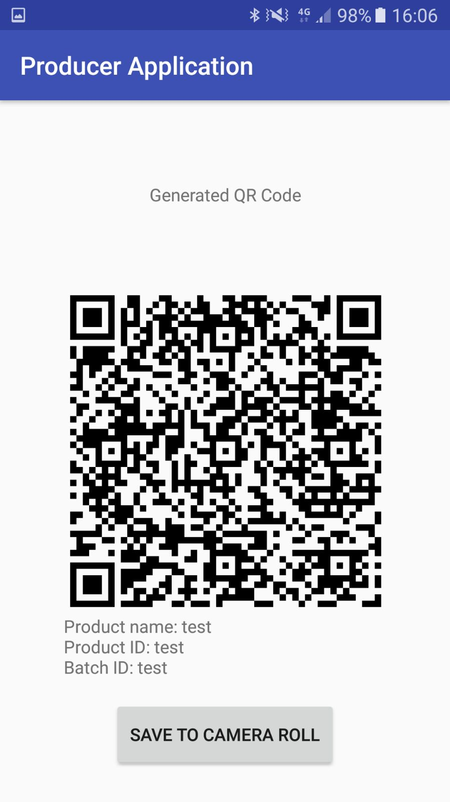

## Task 2 – Move a Product to another Producer

Step 1. Open the application and select *Move Product.*



Step 2. Scan the required Producers and Product. The *Scan Producer QR* is the private QR code of the current producer and the *Scan Next Producer QR* scans the public QR of the next Producer.

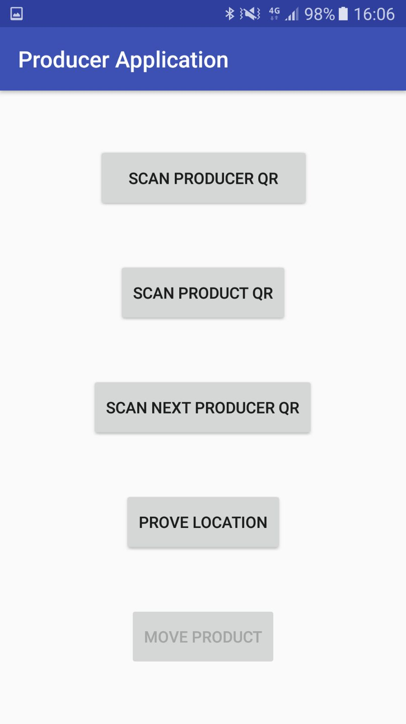

Step 3. Press the *Prove Location* button and the following screen will be displayed.

**Note:** The Bluetooth beacon and the Android device running the Producer Application will need to pair Bluetooth before this section of the application can be used.

**Note:** The Bluetooth Beacon will need to be enabled and within range for this step.

Step 3.1. Press the *Connect to Device* button to bring up previously paired devices. Select the device that is running the Bluetooth Beacon Application.

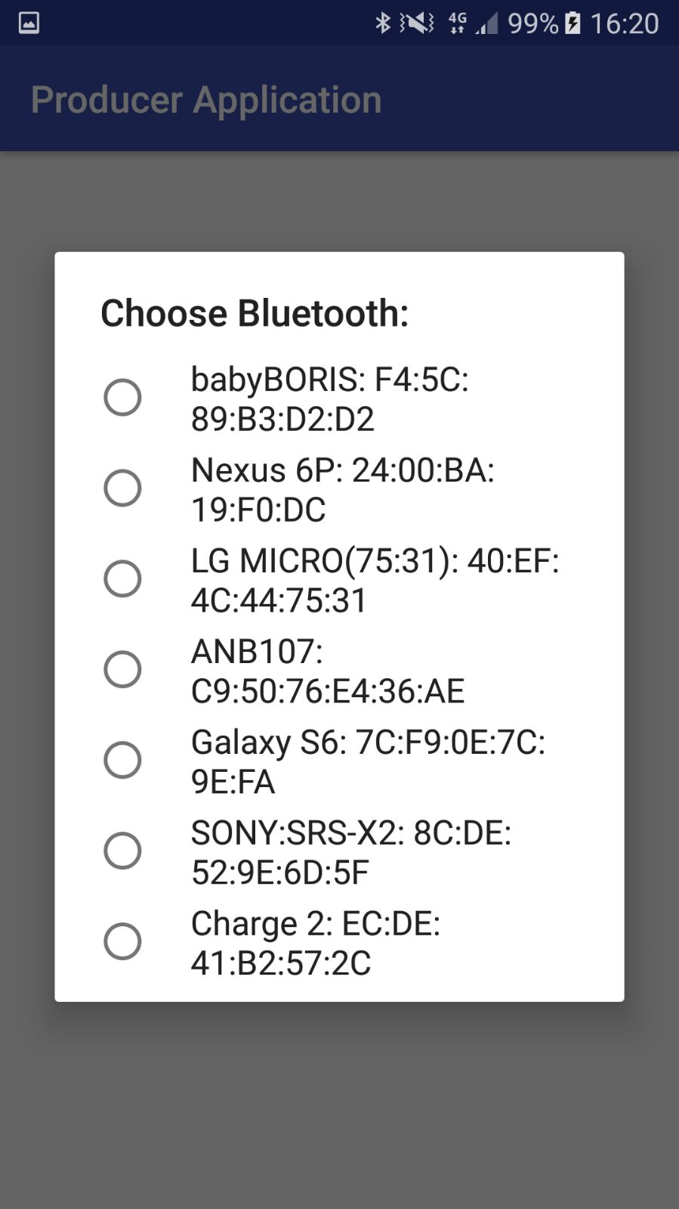

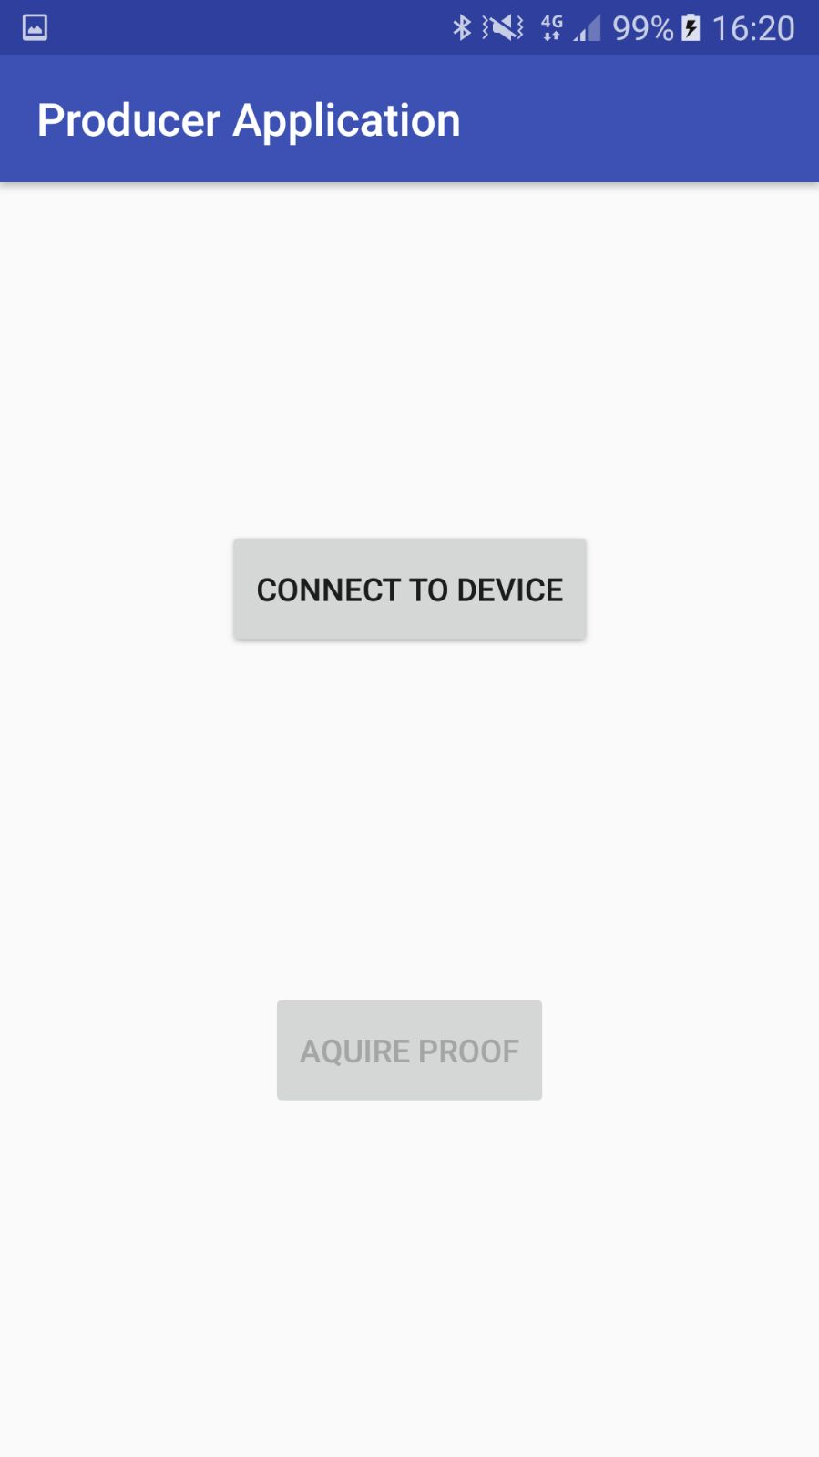

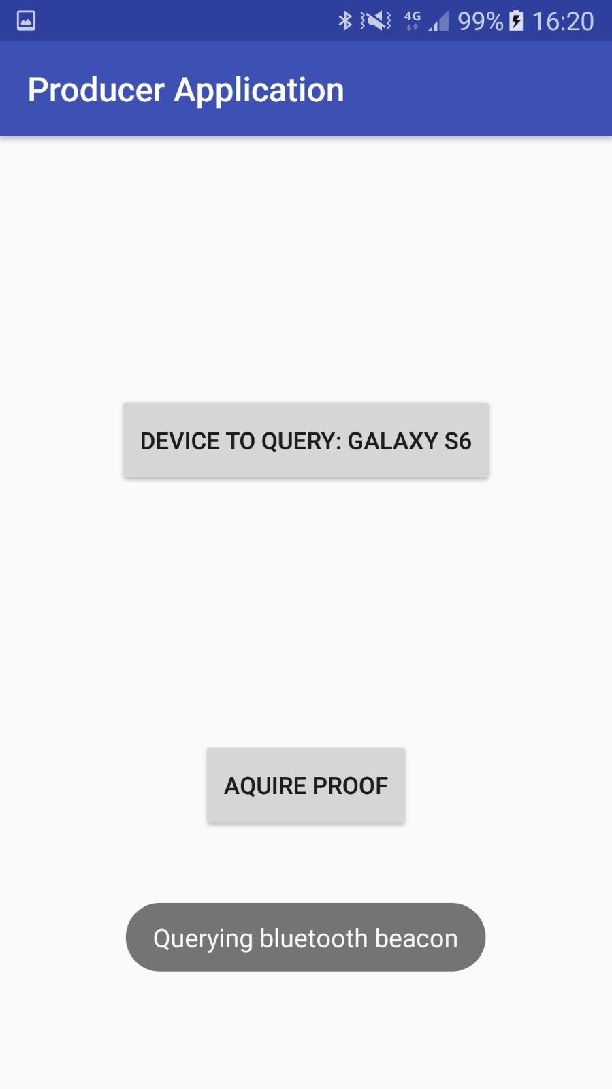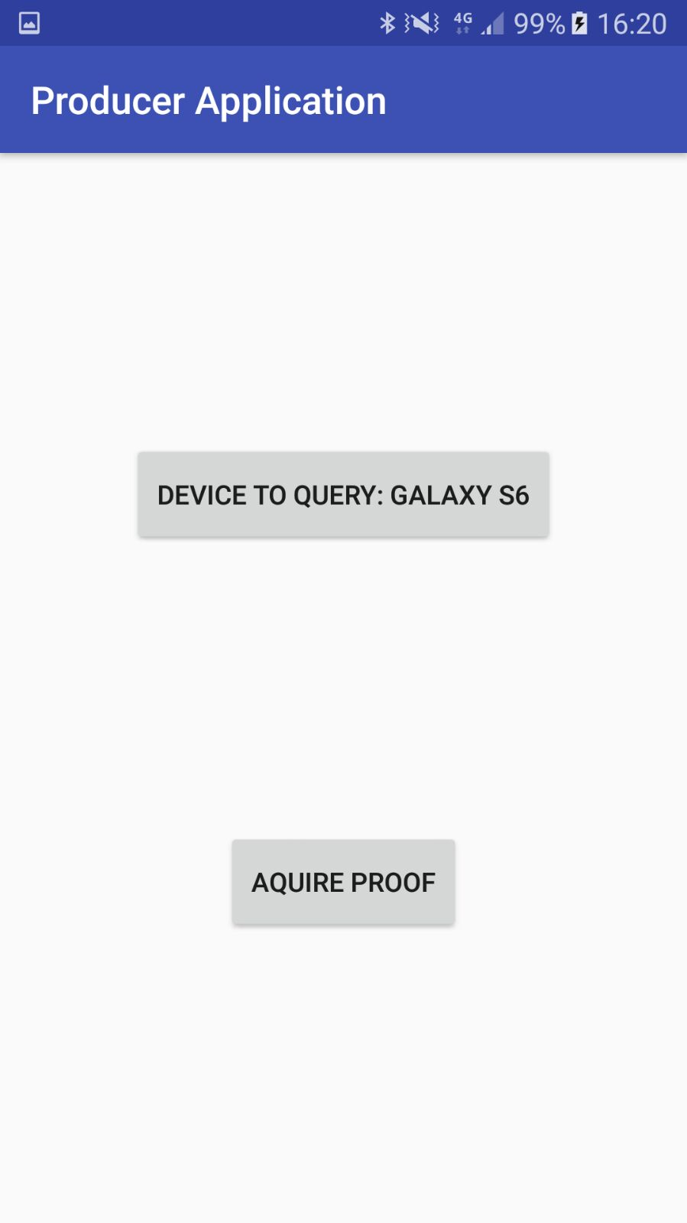Step 3.2. The upper button should display the device that is going to be queried. When ready, press the *Aquire Proof* button to retrieve proof of location from the beacon

If the connection succeeds and the Producer receives data back the message *Proof of location obtained* will appear. Once all requirements have been meet the *Move Product* button will to clickable, it needs to be clicked for the next step.

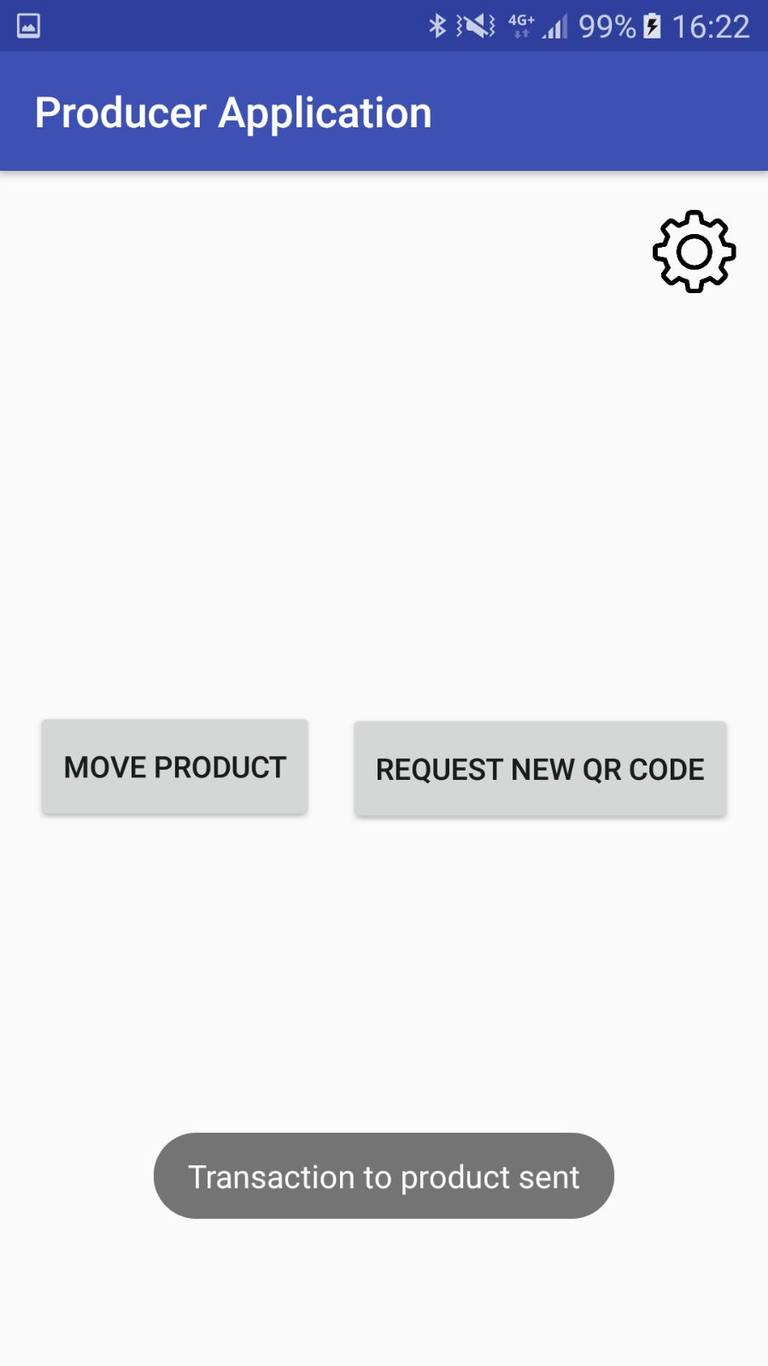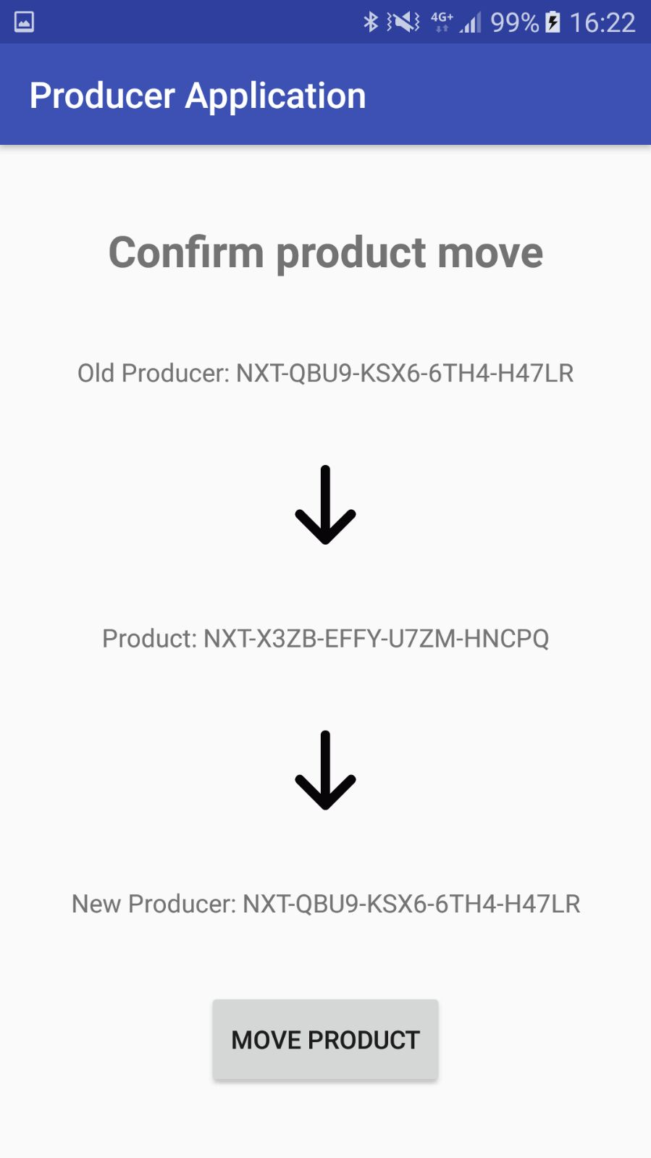Step 3.3. A confirm screen will appear confirming the move of the product between the two producers. Press *Move Product* to initiate the transfer. Once the button is pressed the data will be sent to the Blockchain and caching server.